**Year 10 Physics Revision 2**

1. This table shows the speed of Rhys, Brodie and Nick racing their bikes over time.

|  |  |
| --- | --- |
| **Speed of bikes (m/s)** | **Time (s)** |
| 22 | 2 |
| 23 | 4 |
| 25 | 6 |
| 32 | 8 |
| 32 | 10 |

Describe what happened in Rhys, Brodie and Nick’s journey over time?

____________________________________________________________________________________________________________________________________________________________________________________________________________________________________________________________________________________________________________

1. Yr 10 student’s tested new toy car designs

[](http://www.google.com.au/url?sa=i&rct=j&q=ticker+tape+speed&source=images&cd=&cad=rja&docid=wMhrNsjROP9a0M&tbnid=vzACHjSPZdrteM:&ved=0CAUQjRw&url=http://www.nileswestils.com/ILS/Acceleration.html&ei=-tA7UrGqKIfdkgXOt4HIBA&psig=AFQjCNH19iGDLCD5X9W_FaHQYkKvniD58g&ust=1379738197384806)

**Pako’s CAR**

**Fenton’s CAR**

**Paulo’s CAR**

**In the experiment which student’s car was the fastest? Why?**

**______________________ ___________________________________________________**

**Which students car will reach the end of the ramp**

**In second place ____________________**

**in last place ____________________**



3. Chloe, Tehanee, Akudut, and Langley run a marathon

The distance travelled is: *______________________*

The displacement is ___________________________

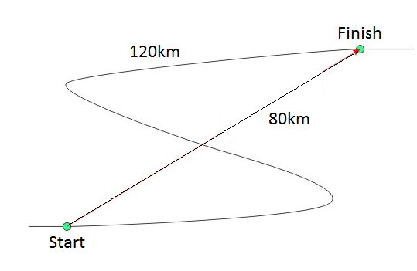

4. Duot rides his bike with a constant speed of 5 m/s. It takes 72 seconds to get to the shop. Calculate how far away the shop is.

**SHOW ALL OF YOUR WORKING OUT.**

Distance= average speed x time d = v x t

d= v= t=

5. Sinay, Rujing & Allie ride their bikes 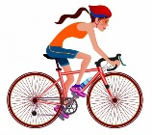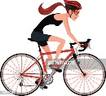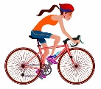

What distance do their bikes, ridden at a speed of 12 centimetres per second, cover in an 10 minutes? (Distance = Speed x Time)

1. If Denando and Thinh

apply a 80 N force to a 122 kg box The box will accelerate at:





7. Nika, Jake and James run three laps of the oval starting and finishing at the same point on the track. If the track is 400 metres

What are the displacement at the end of the race?________________

What distance did the boys run? ____________

1. What happens in each of these unbalanced forces?

James 650N Andy 200N

______________________________________

Marco 96N Jaylen Keagan 105N

 ______________________________________

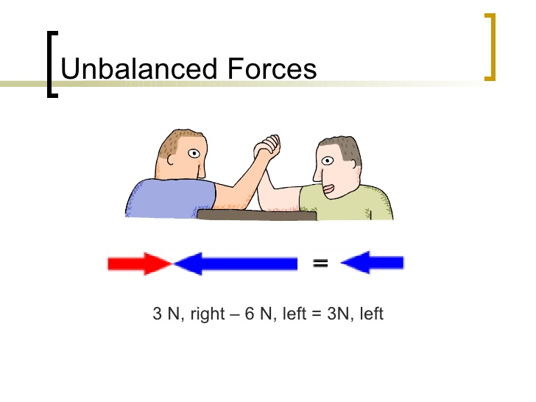______________________________________

Merhawi 65N vs Grason 68N

